SEED Manual for Containers (Docker)
Docker - an open-source project that automates the deployment of software applications inside containers by providing an additional layer of abstraction and automation of OS-level virtualization on Linux.
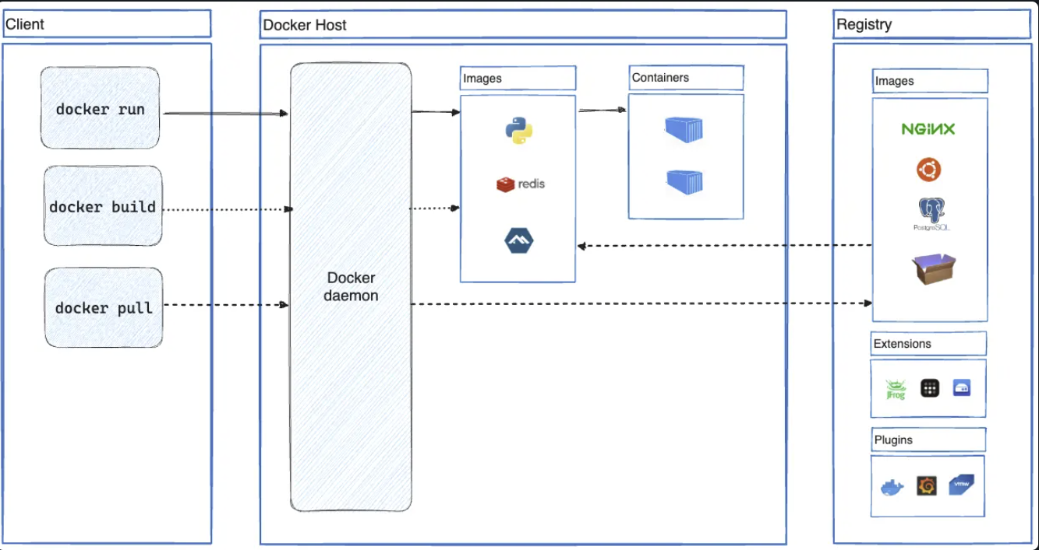
Provides the ability to package and run an application in a loosely isolated environment called a container.
- Abstraction - process of hiding complex details and exposing only the necessary parts
- OS-level virtualization - method of creating multiple isolated user-space instances (containers) on a single operating system kernel, allowing efficient resource usage.
Docker daemon (dockerd) - listens for Docker API requests and manages Docker objects such as images, containers, networks, and volumes
Docker client (docker) – uses docker API to send commands
Docker registries - stores Docker images, looks for images on Docker Hub
Docker objects - images, containers, networks, volumes, plugins, and other objects.
- Images = read-only template with instructions for creating a Docker container
image is a lightweight, standalone, and executable package that contains everything needed to run a piece of software (code...)
- Containers = runnable instance of an image.

Virtual machines –
hypervisor-based virtual machines - hypervisor allows multiple operating systems (OSes) to run concurrently, each in its own isolated environment.
Virtualization - allows multiple virtual machines (VMs) to run on a single physical machine, sharing hardware resources efficiently.

Setting up a LAN
YAML stands for "YAML Ain't Markup Language
docker-compose.yml - defines two services (web and database), specifying the images to use and their configurations

Commands
docker run
docker pull
docker push
ps aux | grep orca == kill voice over
kill id

